Travel & Tourism Management System(TMS)



Shahroz Khalid_ SAP_53531
Basit Ali_ SAP_54596

Supervised By

Mr. Usman

RIPHAH INTERNATIONAL UNIVERSITY I14_ISLAMABAD
December, 2025
Table of Contents

- Introduction
1.1 Overview
1.2 Objectives
- System Overview
2.1 Key Features
2.2 Functional Requirements
  - 2.2.1 User Module
  - 2.2.2 Dashboard Module
  - 2.2.3 Admin Module
2.3 Non-Functional Requirements
- System Design
3.1 Architectural Design
3.2 Modules
3.3 Database Schema / UML Class Diagram
- Implementation
4.1 Technologies Used
4.2 Code Highlights
- Testing
5.1 Testing Methodology
5.2 Test Cases
- Challenges
6.1 Database Integration
6.2 UI Responsiveness
- Output and Results
  - Login Interface
  - Dashboard Interface
  - Packages, Hotels & Destination Interface
  - Payments & SQL Interface
- Conclusion
- Future Enhancements

Final Report on Travel and Tourism Management System

- Introduction:

The Travel and Tourism Management System is designed to streamline and enhance the experience of users planning their travel activities. The system provides functionalities for users to manage personal details, explore and book packages, view hotels, and utilize additional tools like calculators and notepads. The system also facilitates administrative operations such as updating user details and managing travel packages.

- Objective
The primary goal of this project is to create a user-friendly platform for organizing and managing travel-related tasks efficiently.

- System Overview:

The system is built using Java Swing for the graphical user interface (GUI) and employs a relational database for backend data management. The application includes features for user authentication, dashboard navigation, and various travel management options.

- Key Features:

User Authentication: Secure login with a username and password.
Options to sign up, recover forgotten passwords, or manage accounts.

Dashboard: Centralized access to all functionalities through an intuitive panel.

- Travel Management Functionalities:
- Add, update, view, and delete personal details.
- View and book travel packages.
- Manage hotel bookings and view booked hotels.
- Explore destination options.
- Additional Tools:

- Access to a system calculator and notepad.
- "About" section to provide application details.

- Functional Requirements:

- User Module
Authentication:
- Login using valid credentials.
- Recover password in case of forgotten credentials.
Account Management:
- Users can create accounts via the Sign Up feature.
- Update or delete personal details as needed.
- Dashboard Module
Travel Packages:
- View available packages and check details.
- Book packages and view booking history.
- Hotel Management:
- Browse hotels and book rooms.
- View previously booked hotels.
- Payment and Destinations:
- Access payment options.
- Explore destinations based on preferences.
Tools:
- Open system calculator or notepad for quick calculations or notes.
Admin Module
- Manage packages, bookings, and user data.
- View and update details of registered users.

- Non-Functional Requirements:
Performance:
- The system should respond to user interactions within 1-2 seconds.
- Data processing (e.g., booking packages) should not exceed 3 seconds.
Scalability:
- Designed to handle up to 1000 concurrent users with minimal latency.
Usability:
- Intuitive and user-friendly interface with clear navigation.
- Accessibility for non-technical users.
Security:
- Secure authentication with encrypted storage of passwords.
- Input validation to prevent SQL injection attacks.
Reliability:
- Minimal downtime, with a failure rate below 1% in a given year.
- Recovery mechanisms to handle unexpected crashes.

- System Design:
Architectural Design
The system follows a client-server architecture:
- Client-side: Java Swing-based GUI for user interaction.
- Server-side: A database management system to store and retrieve data.

Modules:
- Login Module:
  - Verifies user credentials and grants access to the dashboard.
- Dashboard Module:
  - Central hub for accessing all features, including travel and hotel management.
- Utility Module:
  - Provides additional tools like calculator and notepad.

Database Schema:
- Tables:
  - Users: Stores user details (username, password, contact, etc.).
  - Packages: Details of travel packages.
  - Bookings: Tracks user bookings.
  - Hotels: Information on available hotels.
UML/ CLASS DIAGRAM
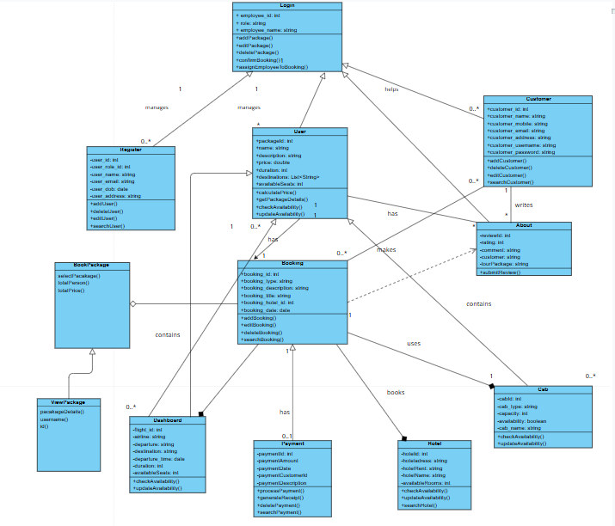

- Implementation:

Technologies Used:
- Programming Language: Java
- GUI Framework: Java Swing
- Database: MySQL
- Tools: NetBeans IDE, JDBC for database connectivity

Code Highlights:
- Splash Screen: Provides an animated startup experience.
- Login System: Secure authentication integrated with the database.
- Dashboard: Intuitive navigation using panels and buttons.

- Testing:

Testing Methodology:
- Unit Testing:
  - Individual modules (e.g., Login, Dashboard) were tested for correct functionality.
- Integration Testing:
  - Ensured seamless interaction between modules like Login and Dashboard.
- System Testing:
  - Validated the entire application for end-to-end use cases.

Test Cases:

Test Case | Expected Result | Outcome
Login with valid data | Successfully navigate to the dashboard | Passed
Invalid Login data | Display error message | Passed
Book a Package | Booking confirmation | Passed
View Booked Hotel | Display book hotels list | Passed

- Challenges:

- Database Integration:
  - Challenge: Efficiently managing multiple database connections.
  - Solution: Implemented connection pooling to optimize database access.
- UI Responsiveness:
  - Challenge: Ensuring smooth animations on various screen sizes.
  - Solution: Used adaptive scaling for dynamic layouts.
- Output/Results

- Login Interface

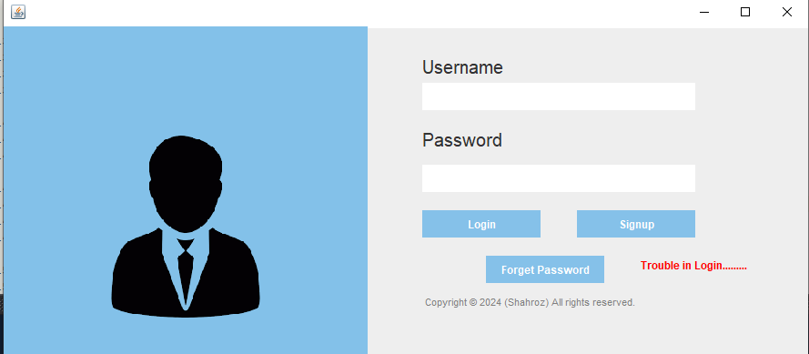 | 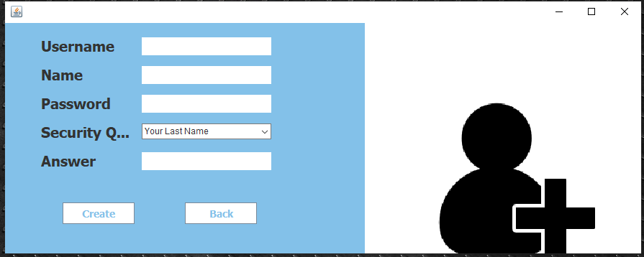
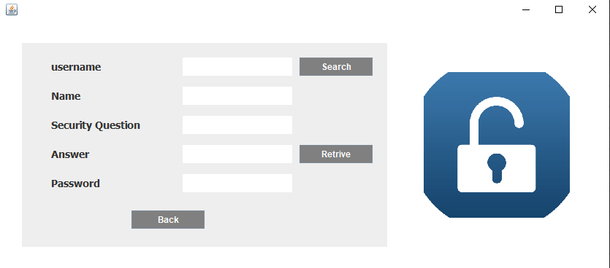 | 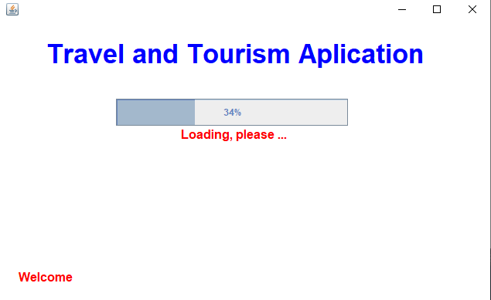

- Dashboard Interface

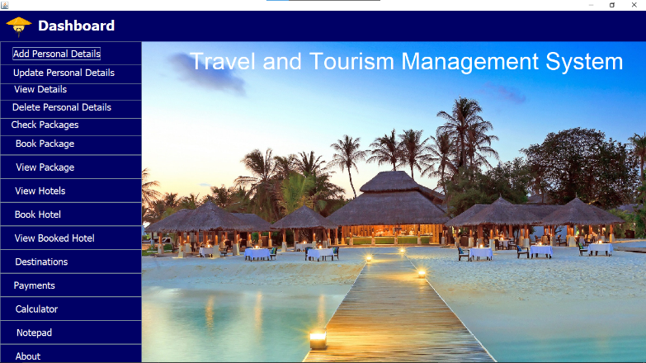 | 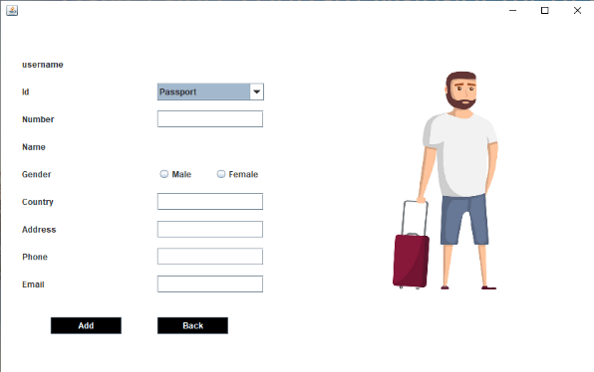
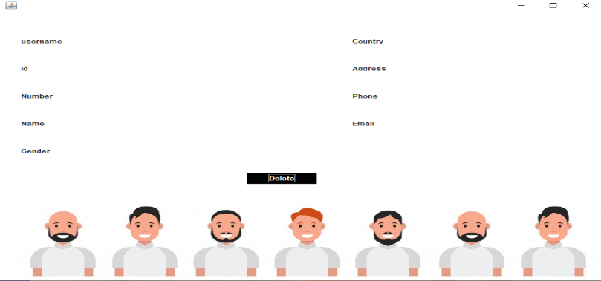 | 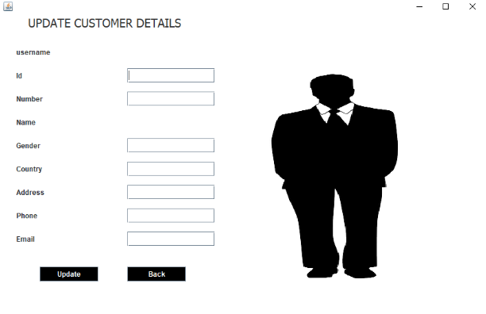

- Packages, Hotels & Destination Interface

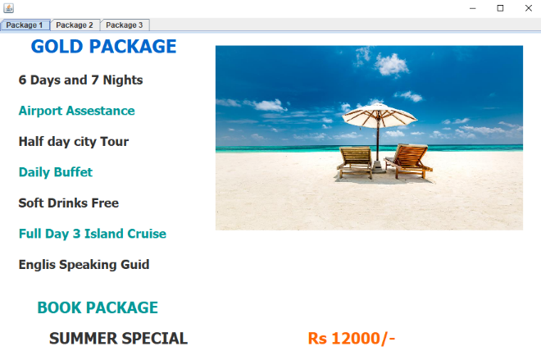 | 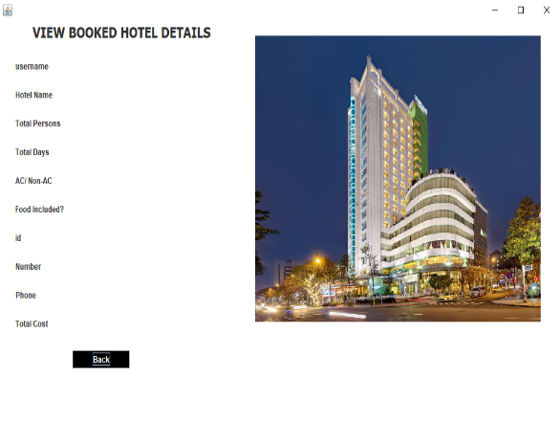
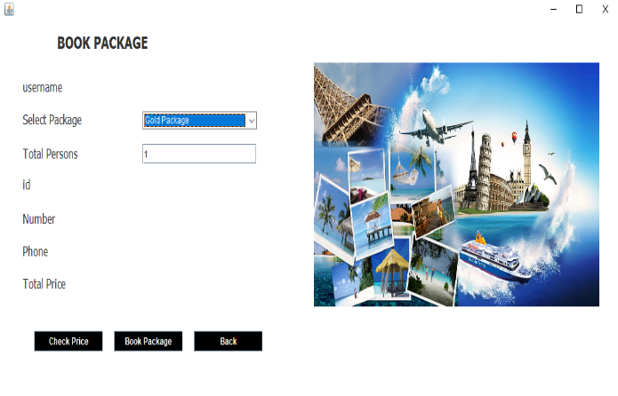 | 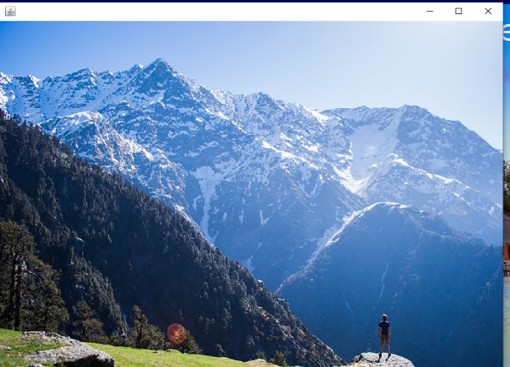

- Payments & SQL Interface

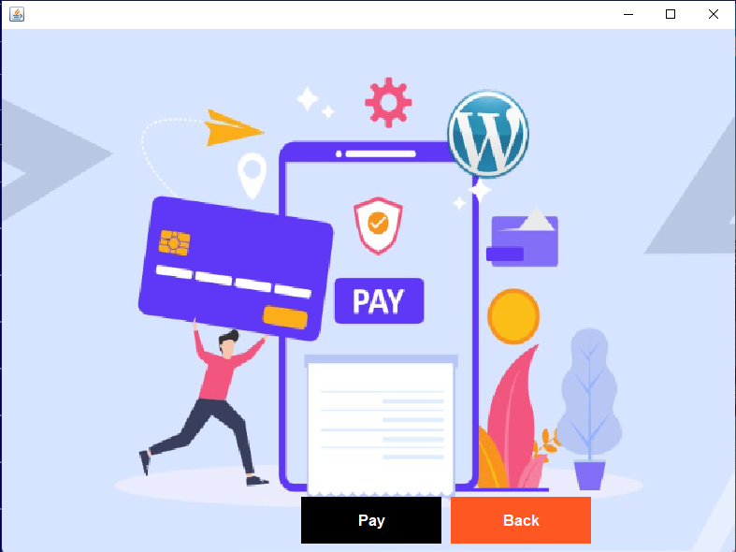 | 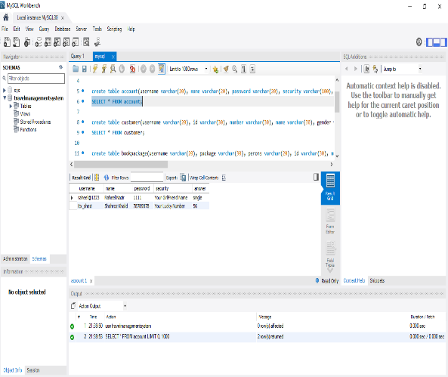
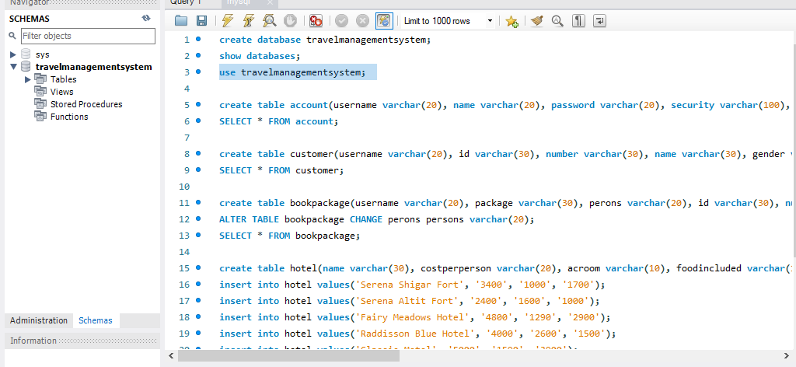 | 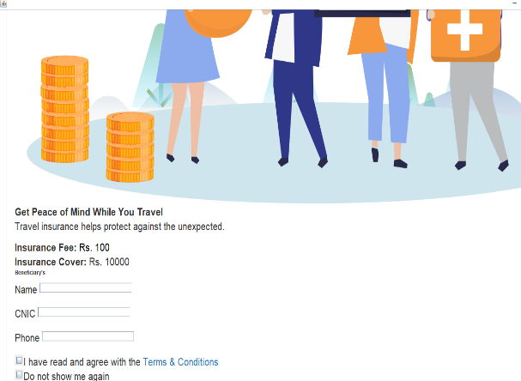

Conclusion:
The Travel and Tourism Management System successfully meets its objectives by providing a comprehensive platform for managing travel needs. It is user-friendly, scalable, and secure, making it suitable for individual travelers and administrative tasks.
Future Enhancements:
- Mobile application support for better accessibility.
- Real-time notifications for bookings and offers.
- Integration with payment gateways for seamless transactions.

GITHUB Link:

- Module 1 (CLI):

https://github.com/SHEHROZ53531/Travel-Management-System-Module-1-CLI-.git

- Module 2 (GUI):

https://github.com/SHEHROZ53531/Travel-Management-System-Module-2-GUI-.git

:

